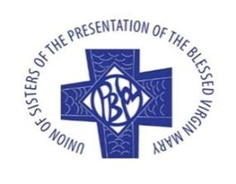
Presentation Sisters Ireland
Child Safeguarding Policy
Statement
The Gospel teaches the importance of ensuring that the Catholic Church community is a warm, welcoming and safe place for children.
Let the little children come to me, and do not hinder them, for the kingdom of God belongs to such as these. Truly I tell you, anyone who will not receive the kingdom of God like a little child will never enter it. (Mark 10:14-15)
Children are gifts from God, to be cherished and recognised for the joyful contribution they make as valued members of the Church. Our challenge is to follow the example of Jesus in cherishing them.
Safeguarding is key to this important task and should be seen, not as a burden, but as an opportunity to embrace and encourage children’s ministry, following the example of Jesus Christ.
This Church body pledges to safeguard children and young people from harm and to support them in their development as valued and integral members of the Catholic Church in Ireland. The Church’s ministry will be inclusive and will uphold their rights. Consistent with Gospel values, and with civil and criminal law, those who minister will do so with dignity and integrity, honouring their calling to ensure that children and young people are welcomed, cherished and protected, following the example set by Jesus.
This Safeguarding Children Policy will be honoured and complied with by all ordained clerics, by vowed female and male religious, and by all lay staff and volunteers in the Catholic Church in Ireland.

Safeguarding Contact Person: Lois Greene; Tel: 022 26411
DLP: SW – Sheila Kelleher, safeguarding@presentationsisterssw.ie
DLP: NE – Margaret Mary Healy, nesafeguarding@gmail.com
Statutory Authorities:
Gárdai: T: 1800 555 222; National Protective Services Bureau, Dublin: T: 01 666 3430
Local Gárdaí: T: 025 82100
Tusla: T: 01 771 8500; Local: 022 54100; T: 021 4923503; T: 066 7195620; T: 061 482792

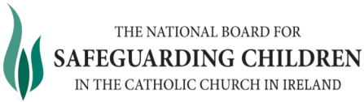

T: (00353) 1 5053124

W: www.safeguarding.ie

